Pressure gauge case materials

Cases are available in a wide variety of materials. The material choice is generally determined by the demands of the application. The more demanding the environment, the more rugged the case construction, for example polypropylene or stainless steel for industrial applications versus aluminium or steel for construction or commercial applications.

The following is an overview of the case materials available and their main application:

- Drawn steel – most economical selection
- Cast iron – for more rugged applications
- Brass – for decorative and or anti-magnetic applications
- Aluminium – for limited-weight applications
- Phenolic resin or polypropylene – for use in corrosive applications
- Stainless steel – for use in corrosive, sanitary and food applications.
  - Common stainless-steel variants are 304SS & 316SS.

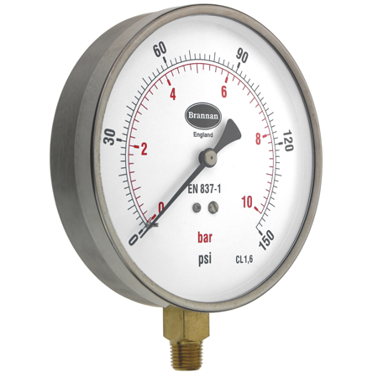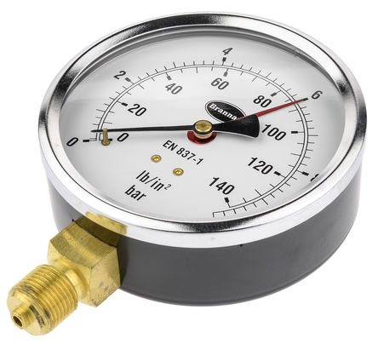
Stainless Steel Case
Drawn Mild Steel Case

We have a variety of pressure gauge cases available – contact sales@brannan.co.uk

